Terraform Final Task

1.Create VPC.
2.Create Internet gateway
3.Create Custom route Table
4.Create Subnet
5.Associate subnet with Route Table
6.Create Security Group to allow port 22.80.443
7.Create a network interface with an IP in the subnet that was created in step 4
8.Assign an elastic IP to the network interface created in step 7
9.Create Ubuntu server and install /enable apache2

Objective
To provision a complete AWS infrastructure using Terraform, including VPC networking, security configuration, network interface, Elastic IP, and deployment of an Ubuntu EC2 instance with Apache2 installed and enabled.

Prerequisites
- AWS Account with Administrator or required IAM permissions
- Terraform installed
- AWS CLI configured using aws configure
- Visual Studio Code (or any Terraform-supported editor)
- Basic knowledge of AWS & Terraform

provider "aws" {
region = "us-east-1"
}
resource "aws_vpc" "vpc" {
cidr_block = "10.0.0.0/22"
tags = {
Name = "vpctask"
}
}
resource "aws_internet_gateway" "igw" {
vpc_id = aws_vpc.vpc.id
tags = {
Name = "Internet gateway"
}
}
resource "aws_subnet" "subnet" {
vpc_id = aws_vpc.vpc.id
cidr_block = "10.0.1.0/28"
availability_zone = "us-east-1a"
tags = {
Name = "public subnet"
}
}
resource "aws_route_table" "vpc" {
vpc_id = aws_vpc.vpc.id
tags = {
Name = "public route table"
subnet = "public subnet"
}
}
resource "aws_route_table_association" "a" {
subnet_id = aws_subnet.subnet.id
route_table_id = aws_route_table.vpc.id
}
resource "aws_route" "route" {
route_table_id = aws_route_table.vpc.id
destination_cidr_block = "0.0.0.0/0"
gateway_id = aws_internet_gateway.igw.id
}
resource "aws_security_group" "sg" {
vpc_id = aws_vpc.vpc.id
ingress {
from_port = 22
to_port = 22
protocol = "tcp"
cidr_blocks = ["0.0.0.0/0"]
}
ingress {
from_port = 80
to_port = 80
protocol = "tcp"
cidr_blocks = ["0.0.0.0/0"]
}
ingress {
from_port = 443
to_port = 443
protocol = "tcp"
cidr_blocks = ["0.0.0.0/0"]
}
egress {
from_port = 0
to_port = 0
protocol = "-1"
cidr_blocks = ["0.0.0.0/0"]
}
}
resource "aws_network_interface" "terraform_eni" {
subnet_id = aws_subnet.subnet.id
security_groups = [aws_security_group.sg.id]
tags = {
Name = "terraform-eni"
}
}
resource "aws_eip" "terraform_eip" {
domain = "vpc"
network_interface = aws_network_interface.terraform_eni.id
tags = {
Name = "terraform-eip"
}
}
resource "aws_instance" "terraform_instance" {
ami = "ami-0b6c6ebed2801a5cb"
instance_type = "t3.micro"
availability_zone = "us-east-1a"
user_data = <<-EOF
#!/bin/bash
apt update -y
apt install -y apache2
systemctl start apache2
systemctl enable apache2
EOF
tags = {
Name = "terraform-FinalTask"
}
}
resource "aws_network_interface_attachment" "eni_attach" {
instance_id = aws_instance.terraform_instance.id
network_interface_id = aws_network_interface.terraform_eni.id
device_index = 1
}
output "network_interface_id" {
value = aws_network_interface.terraform_eni.id
}
output "instance_public_ip" {
value = aws_eip.terraform_eip.public_ip
}
output "allocated_ipv4_address" {
value = aws_eip.terraform_eip.public_ip
}

PROVIDER AND REGION:

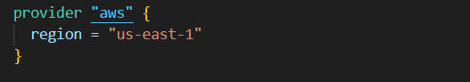

Create VPC
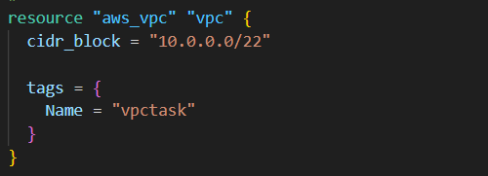

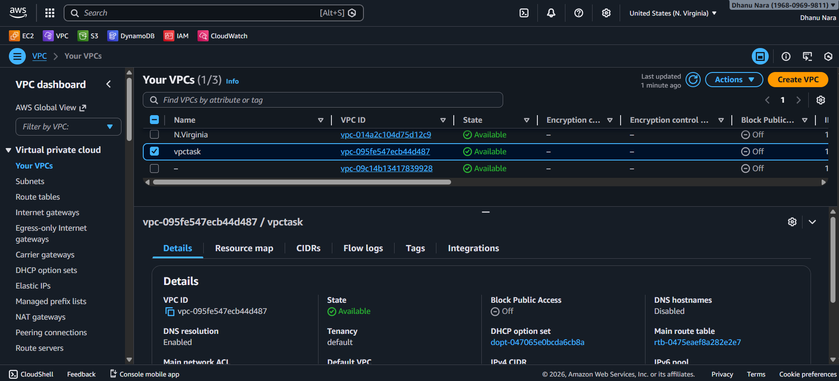

Terraform Resource: aws_vpc
Details:
- CIDR Block: 10.0.0.0/22
- Tagged for identification
Image 1: Terraform VPC configuration
Image 2: VPC (vpctask) created in AWS Console

Create Internet gateway:
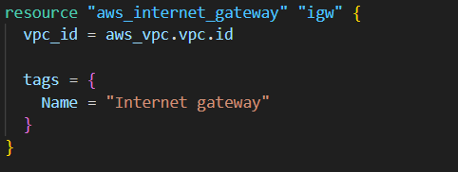

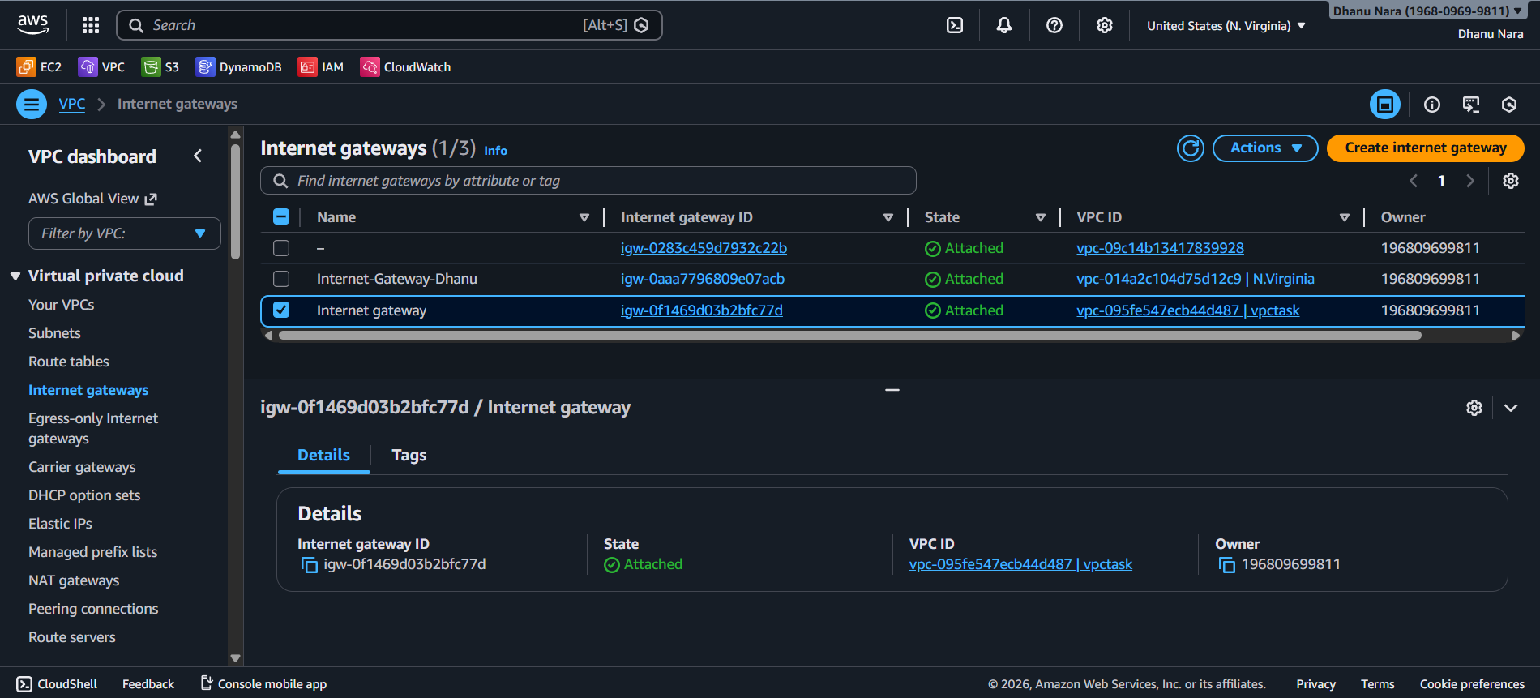
Terraform Resource: aws_internet_gateway
Image 1: Terraform Internet Gateway configuration
Image 2: Internet Gateway attached to VPC in AWS Console

Create Subnet:
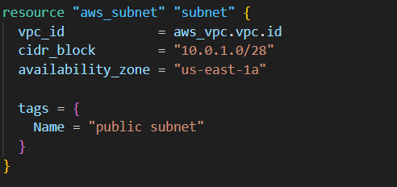
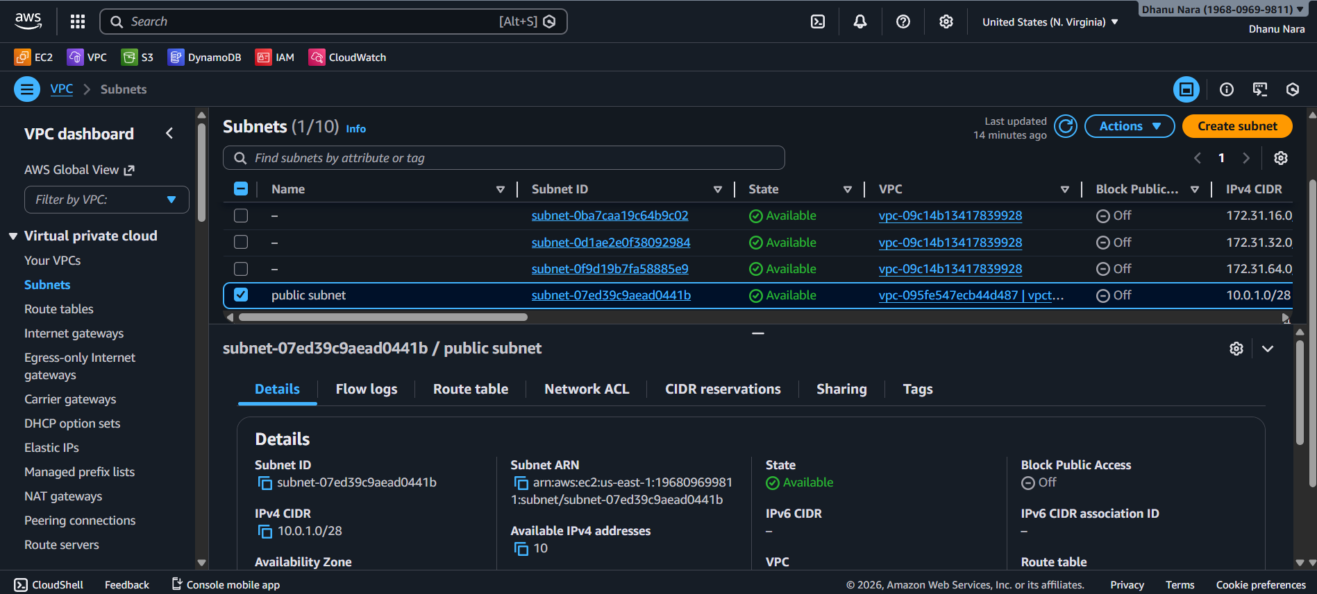
Terraform Resource: aws_subnet
Details:
- CIDR Block: 10.0.1.0/28
- Availability Zone: us-east-1a
📸 Image 1: Terraform Subnet configuration
📸 Image 2: Public subnet created in AWS Console

Create Custom route Table:
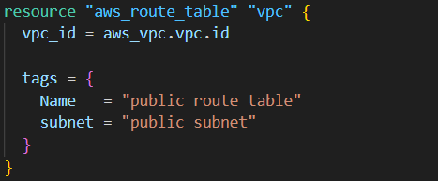

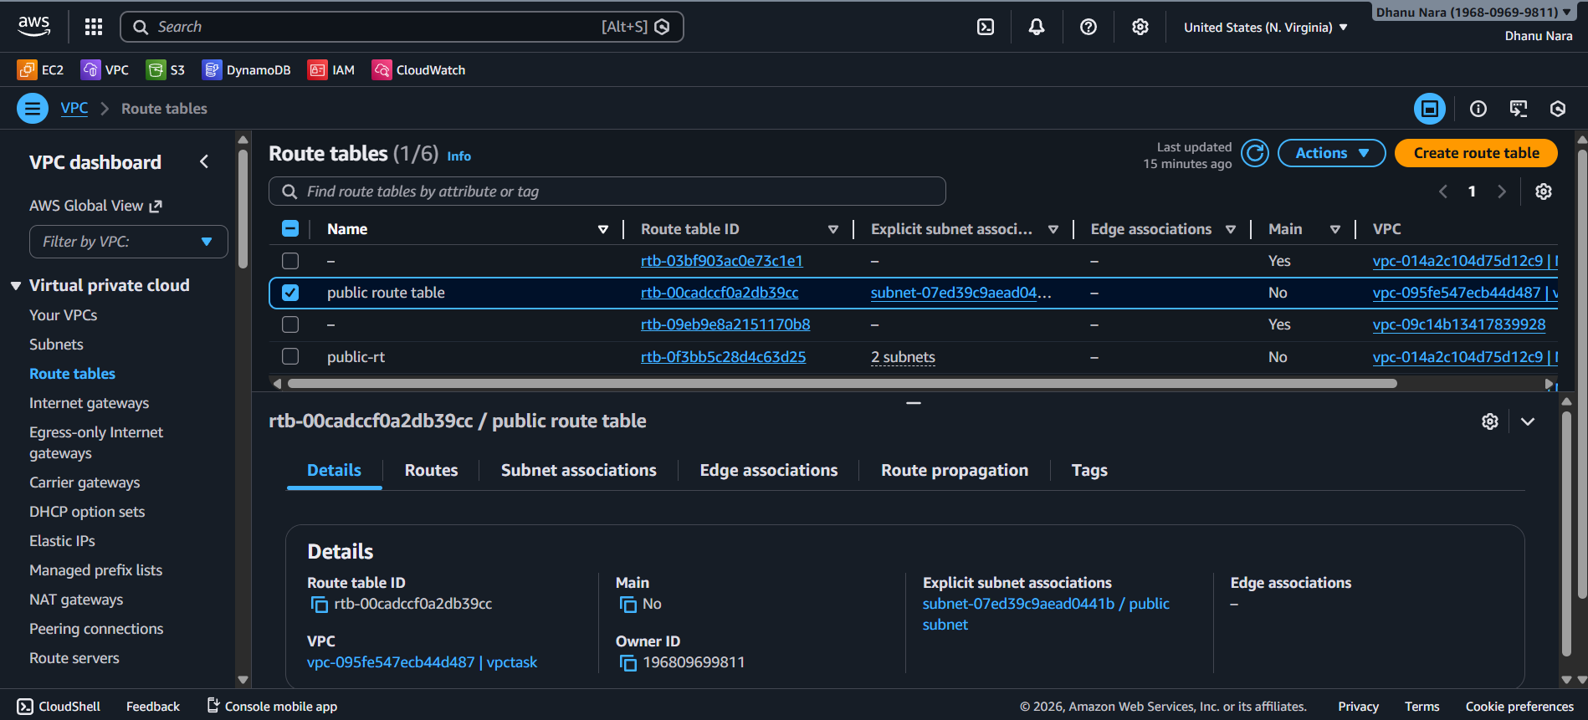
Terraform Resource: aws_route_table
📸 Image 1: Terraform Route Table configuration
📸 Image 2: Route Table visible in AWS Console

Associate subnet with Route Table:
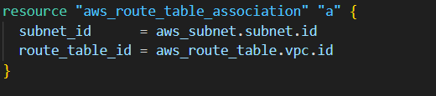
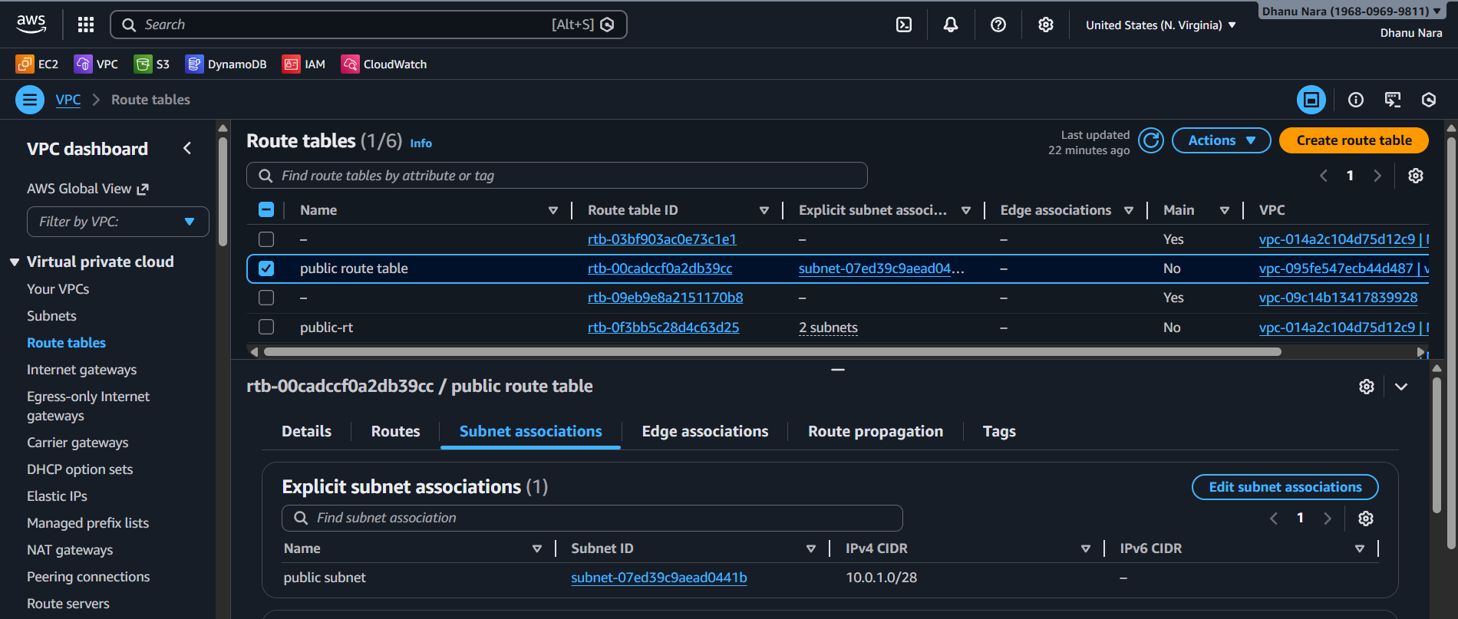
Terraform Resource: aws_route_table_association
Image 1: Terraform Route Table Association code
Image 2: Subnet associated with Route Table in AWS Console

Create Security Group to allow port 22.80.443:
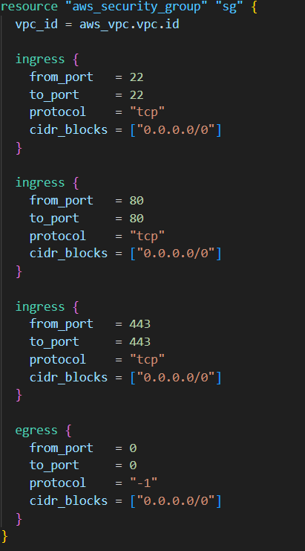
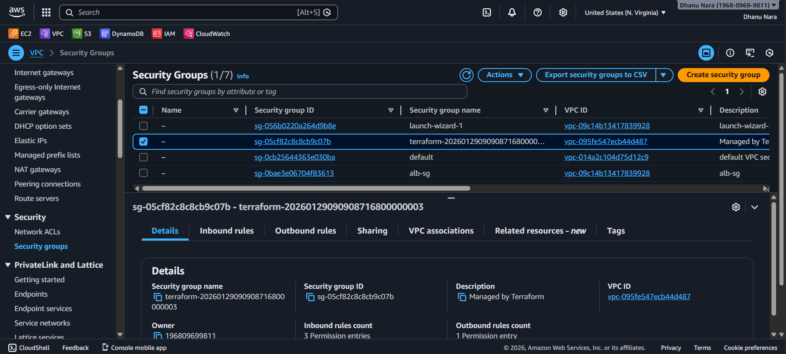
Terraform Resource: aws_security_group
Inbound Rules Allowed:
- SSH – Port 22
- HTTP – Port 80
- HTTPS – Port 443
Outbound Rule:
- Allow all traffic
Image 1: Terraform Security Group configuration
Image 2: Security Group created in AWS Console

Create a network interface with an IP in the subnet that was created in step 4:
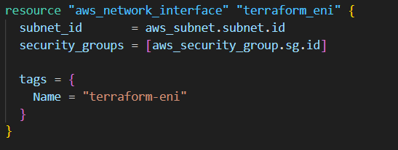
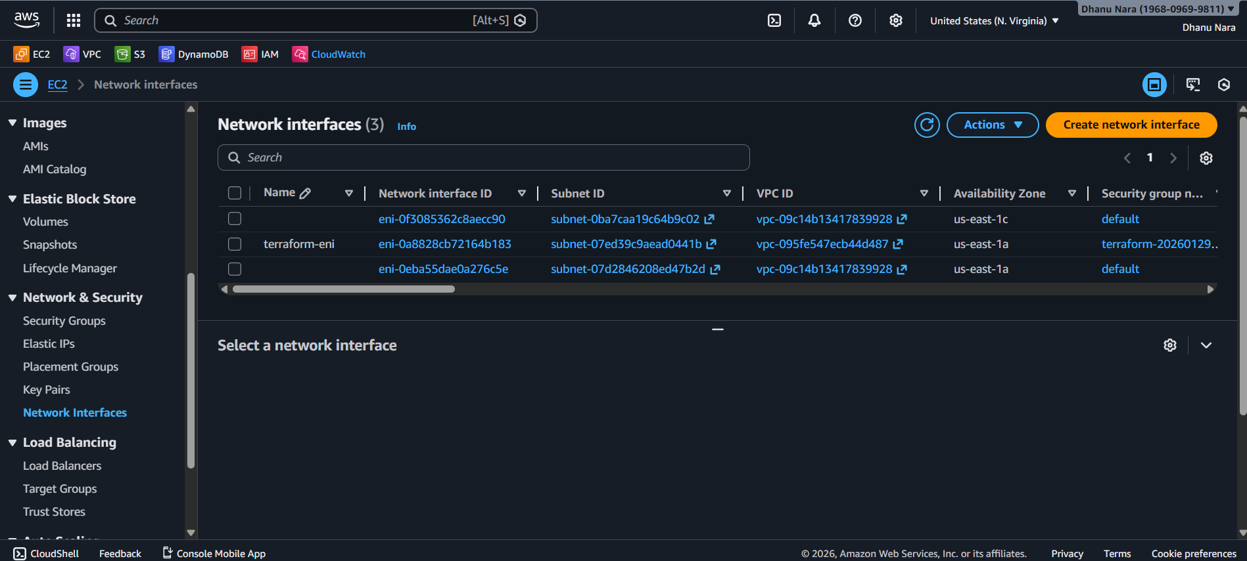
Terraform Resource: aws_network_interface
Image 1: Terraform Network Interface configuration
Image 2: Network Interface visible in AWS Console

Assign an elastic IP to the network interface created in step 7:
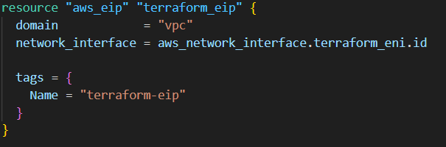
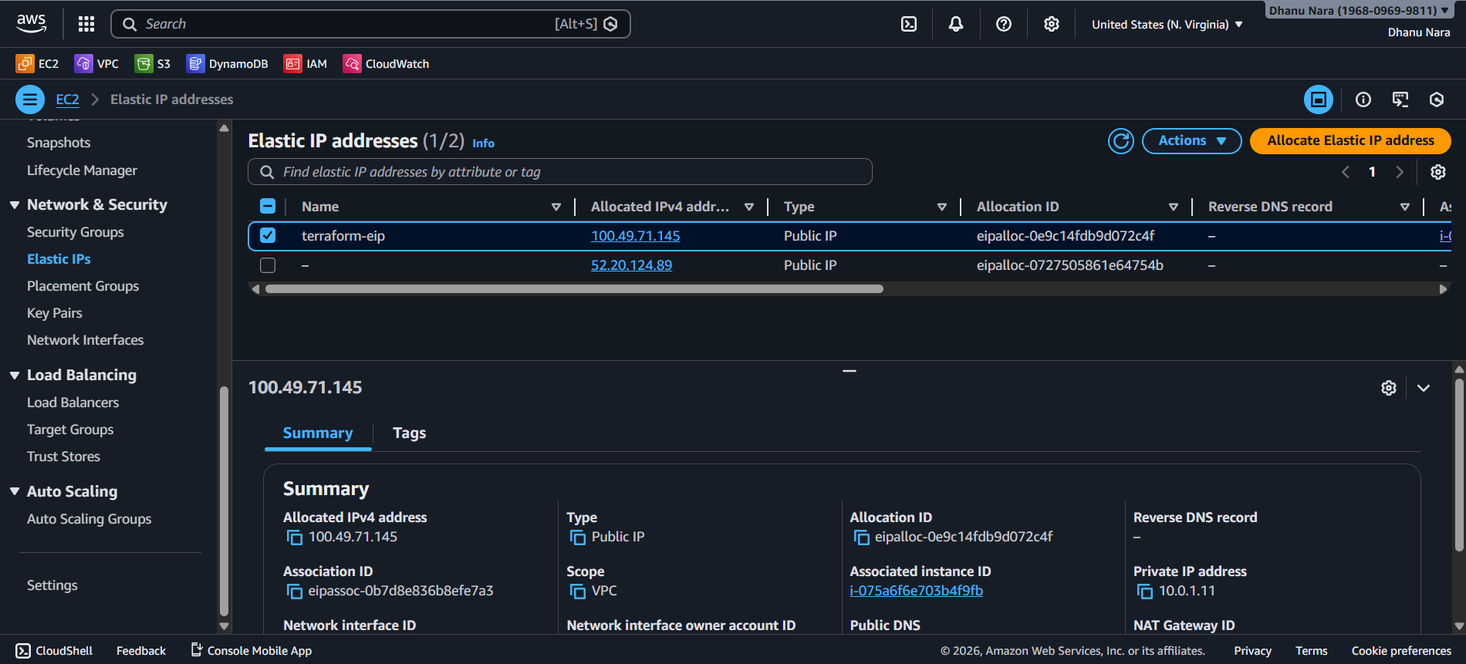
Terraform Resource: aws_eip
Image 1: Terraform Elastic IP configuration
Image 2: Elastic IP associated in AWS Console

Create Ubuntu server and install /enable apache2:
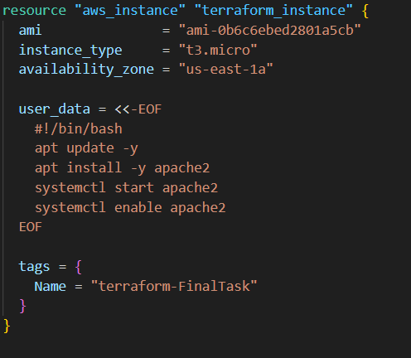
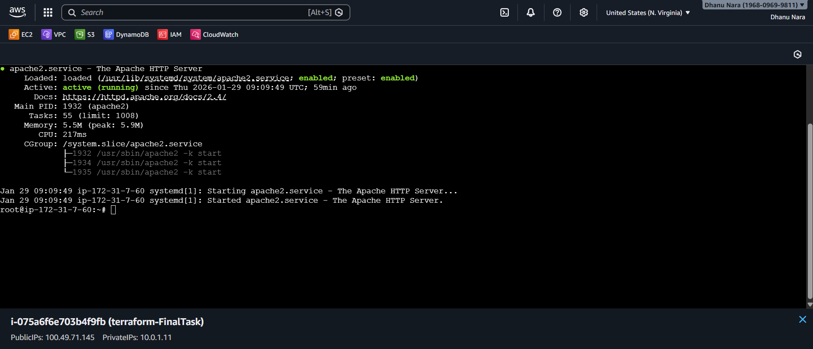
Terraform Resource: aws_instance

User Data Tasks:
- Update packages
- Install Apache2
- Start Apache service
- Enable Apache on boot
Image 1: Terraform EC2 + User Data script
Image 2: Apache service running on EC2 instance

Validation Steps:
- Run Terraform commands:
- terraform init
- terraform plan
- terraform apply
- Verify in AWS Console:
  - VPC, Subnet, Route Table
  - Security Group rules
  - Network Interface
  - Elastic IP attached
  - EC2 instance running
- Access Apache server:
- http://<Elastic-IP>

Conclusion:
The complete AWS infrastructure was successfully provisioned using Terraform.
An Ubuntu EC2 instance was deployed with Apache2 installed and made accessible via Elastic IP.
This task demonstrates Infrastructure as Code (IaC), automation, and reproducibility using Terraform.

